POSTCARD PROJECT
SETTING & THICK DESCRIPTION LESSON

Vocabulary:

- Setting- the place and conditions in which something happens or exists : the time, place, and conditions in which the action of a book, movie, etc., takes place : the rooms, painted backgrounds, furniture, etc., that are used for a scene in a movie or play

- 5 senses: Five natural powers (touch, taste, smell, sight, and hearing) through which you receive information about the world around you.

Visual Thinking Strategy

Canyon de Chelly Navajo- Image of Desert.

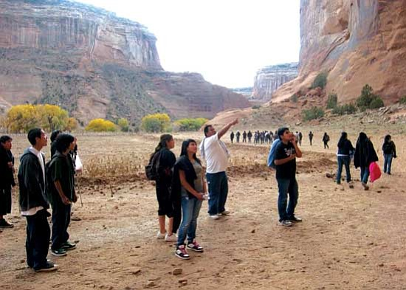
READ:
Canyon de Chelly was established in 1931 as a National Monument encompassing three major canyons. The steep stained walls preserve ancient ruins of the once thriving Anasazi Indians. There are over 700 ruin sites, petroglyphs and cliff dwellings from the prehistoric Anasazi and historic Navajo periods. Navajo people still live within the monument and farm the fertile valleys the way their ancestors did centuries ago.

QUESTIONS:

- What is going on in this picture?

- Use the vocab words setting and 5 senses to write 2 sentences about the image.

What is YOUR favorite place that you have ever been in your whole life?

Draw a digital picture of it and insert it in this doc HERE.

FOLLOW THESE DIRECTIONS VERY CAREFULLY TO INSERT A SCRIBBLE:
- Click INSERT > DRAWING > NEW at the top of the Google Doc menu bar.
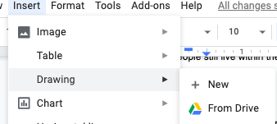

Describe the place below:

Sense | Write a sentence that describes the sense below
Smell
Hear
Touch
Taste
See

Using the above and write a thick description paragraph about your favorite place.

